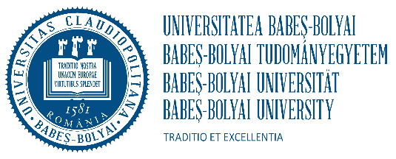
BABEŞ-BOLYAI UNIVERSITY CLUJ-NAPOCA
CENTRE FOR INTERNATIONAL COOPERATION
68, Avram Iancu St., RO – 40 0083, Cluj-Napoca, România
Phone. +40/264/429762 Fax: +40/264/429755
E-mail: ilona.dranca@ubbcluj.ro



STAFF APPLICATION FORM
ACADEMIC YEAR 2024/2025 Erasmus+ with partner countries

This application should be filled in ELECTRONICALLY. You are kindly asked to fill in ALL the fields!

PERSONAL DATA

First name: …………………………………………………………………………………………….

Last name: ………………………………………………………………………………………………

Nationality: …………………………………………………………………………………………...

E-mail: …………………………………………………………………………………………………..

SENDING INSTITUTION

Name: Universidade Federal Fluminense

Address: ………………………………………………………………………………………………..

ERASMUS code of the home university: PIC 99660370 and OID E10212870.

Position at the home university: ……………………………………………………………………….

Home Faculty/Department: ……………………………………………………………………………

E-mail: …………………………………………………………………………………………………

Phone: ………………………………………………………………………………………………….

DATES of visit (day/month/year): ________/__________/______________  TYPE: Erasmus – teaching mobility ( ) Erasmus – training mobility (  Other ……………………………………………………… | )

RECEIVING INSTITUTION

Host university: Universitatea Babeș-Bolyai
Erasmus code: RO CLUJNAP 01
Host Faculty/Department: …………………………………………………………………………….

Contact Person: ……Iloan drancă………………………………………………………………………………….

E-mail: ………………………………………………………………………………………………..

- Teaching programme

Topic | Duration (hours) | Level | Teaching language | Number  of students

- Training programme / Other

Date | Activity

Date and Place Signature

